Congnizant interview

1.Wt is cmd vs entry point

ENTRYPOINT and CMD are similar but separate instructions that complement each other: ENTRYPOINT is the process that's executed inside the container. CMD is the default set of arguments that are supplied to the ENTRYPOINT process

<https://www.atatus.com/blog/docker-cmd-vs-entrypo>

<https://medium.com/container-talks/understand-cmd-and-entrypoint-differences-in-docker-d11105cc5454ints/>

CMD: Sets default parameters that can be overridden from the Docker Command Line Interface (CLI) while running a docker container.

ENTRYPOINT: Default parameters that cannot be overridden while executing Docker Containers with CLI parameters.

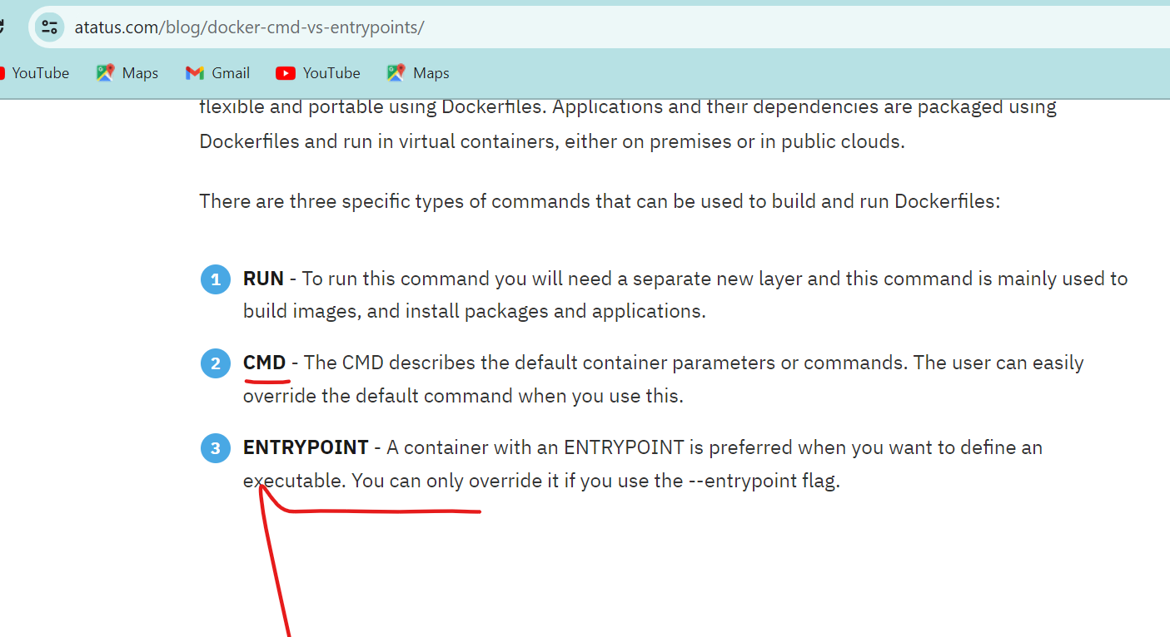

both are same actually

Cmd can be overwrite while excustion of container

Entry point can can't overwrite,

Still entry point can over writte

-entrypoint switch

--switch

2.Did you ever create pipeline right?

<https://learn.microsoft.com/en-us/azure/devops/pipelines/create-first-pipeline?view=azure-devops&tabs=java%2Ctfs-2018-2%2Cbrowser>

<https://www.jenkins.io/doc/book/pipeline/>

<https://www.youtube.com/watch?v=PKcGy9oPVXg>

<https://www.youtube.com/watch?v=vBoOXP6BkDI>

<https://azuredevopslabs.com/labs/vstsextend/azuredevopsprojectdotnet/>

Both Jenkins &azure devops

Shall I take Jenkins or azure devops

Can you please explain Jenkins pipeline

In organisation levels

Most of the project

Infrastructure pipeline

Application pipeline

For example

Application pipeline

Now we ar wrk on Java spring boot application

Our code is git repo or but bucket based upon the project actually

Once code is committed

It is multi branch pipeline declarative

We need check out the code

We need check static code analysis by using the sonar qube

Based webhook trigger the job,

If build job failed,check vulnerability,code quality,after that

Build phase build up over application mostly by using maven

In maven life cycle install and deploy

Which is also used package installation,

Our artifact either jar or war, push into the remote repo,like jfrog,once artifact generated next stage will be container image, where we use docker file,use the docker build command,once it is done we also use remote repository which can be elastic container in awsnecr or acr in azure

It is continuously integration part will be completed

Then we do the continue delivery to develop product environment

Or else it is micro service application will be using k8s

We will be updated value in the helm chart

We are rollout change in the infra

Once everything working well passed to the functional testing

Function testing is the manual job,once everything fine,there will be stable batch will be created , which will be rolled out the production

3.Wt about eks or ecs service in cloud ?

<https://docs.aws.amazon.com/eks/latest/userguide/sample-deployment.html>

<https://k21academy.com/docker-kubernetes/amazon-eks-kubernetes-on-aws/>

kops of aws

<https://medium.com/@mudasirhaji/setup-kubernetes-cluster-on-amazon-eks-56cbbadace04>

<https://www.youtube.com/watch?v=Ojb9Rh0BcvA>

I wrk exp kubernetes on premesise also

Can u please explain the ingress controller?

If u want to expose ur service to external user,

I'f I want have few features like

We need dns route54

We can use multi routing

To actually to avoid the multiple load balancer

To avoid extra cost that actually we can route traffic in n backend services

Use the nginx controller and where application load balancer utilizes basically

4.U have work experience in terraform

I have wrk experience

5.Wt is use of terraform modules

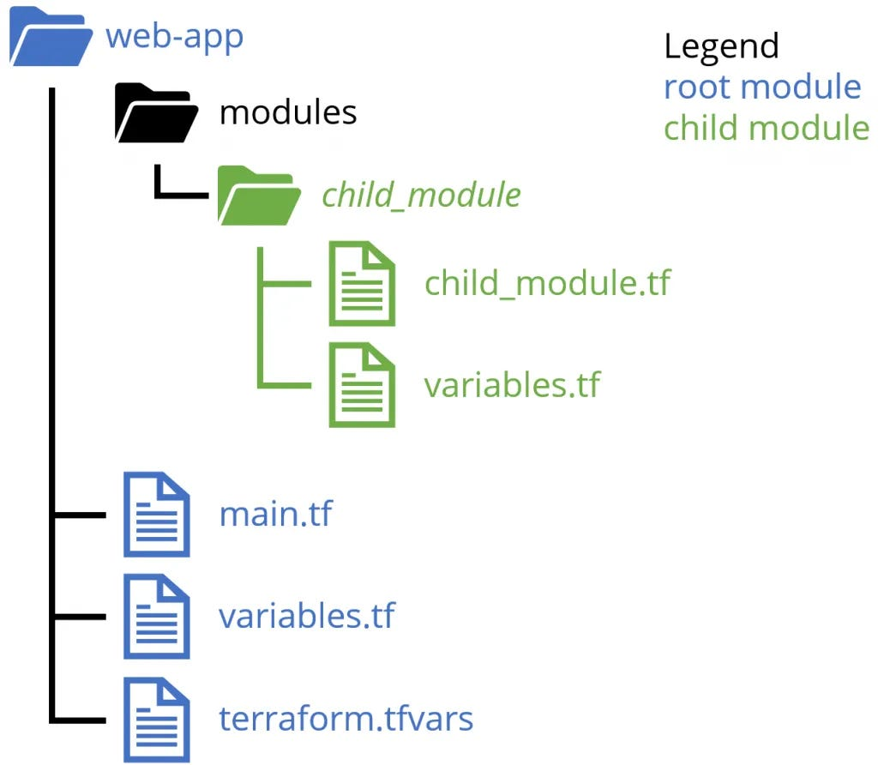

<https://www.squadcast.com/blog/creating-your-first-module-using-terraform>

<https://www.youtube.com/watch?v=xBWmBPVTums>

Imagine redeploy service best way it is use nodules

Modules nothing but terraform code

We will push into the repository and we r going to tag it

In future if u want to change it,

Important point here it is output values

If u want exchange the information we need put the output.values

Without output values we can't re use the values

6.Can you explain the azure devops ?

<https://azuredevopslabs.com/labs/vstsextend/azuredevopsprojectdotnet/>

7.https://learn.microsoft.com/en-us/training/modules/create-a-build-pipeline/

A part from creating pipeline

Creating organisation as well as creating the projects

Creating the services

Sharing the other projects as well

We used one integration cpu 16gb ram across multiple projects

Ans also creating with azure key valuts actually

Which will save the password

And also variable group configuration in azure ad and then we give the permission actually

8.U have experience on azure active directory as well?

How do you explain Azure Active Directory?

Azure Active Directory comprises a database (directory) that records things like what users there are and who's allowed to do what, and set of services that enable your employees to sign in (authentication) and access only the IT resources they're allowed to (authorization).

What is Azure Active Directory used for?

Azure AD is intended for managing access to cloud-based applications and servers that use modern authentication protocols such as SAML 2.0, OpenID Connect, OAuth 2.0 and WS-Federation. Azure AD manages access through user accounts, which carry a username and a password.

Active directory synchronised with the azure infra

9.Wt are service u most experienced in cloud?

Virtual machines

Virtual network

Load balancer

Iam

In aws and azure

10.Wt is different between the application and network load balancer

<https://aws.amazon.com/compare/the-difference-between-the-difference-between-application-network-and-gateway-load-balancing/>

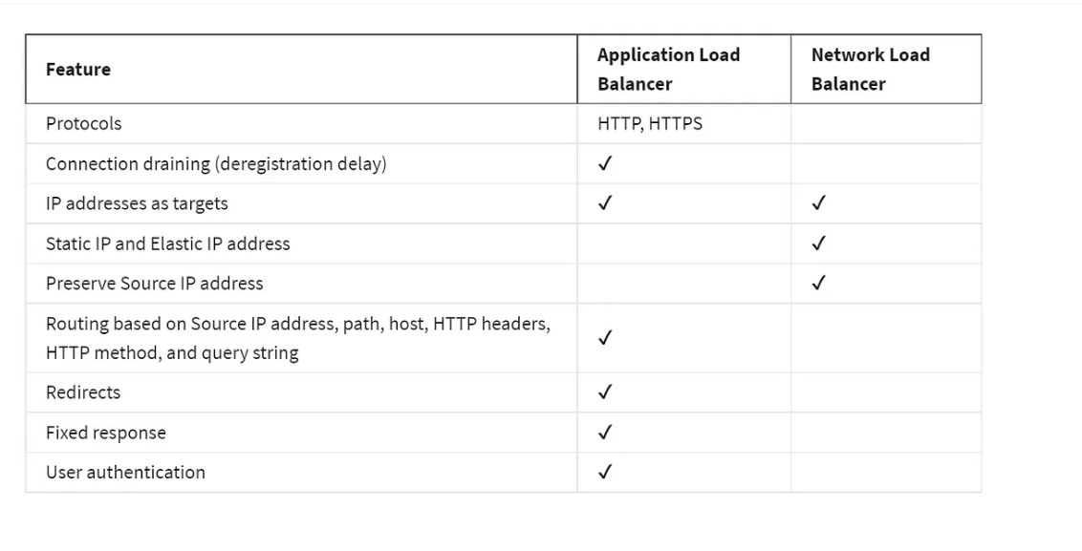

It is l4 layer

If use chat box and online meeting use to tcp and UDP protocol

Application

Https, http

11.Wt is use case of target group?

Each target group is used to route requests to one or more registered targets. When you create each listener rule, you specify a target group and conditions. When a rule condition is met, traffic is forwarded to the corresponding target group

Which is connect the port it is backed port

We have multiple target group with same machine

12.Wt is diff load balancer vs target group?

<https://aws.amazon.com/blogs/aws/new-application-load-balancer-simplifies-deployment-with-weighted-target-groups/>

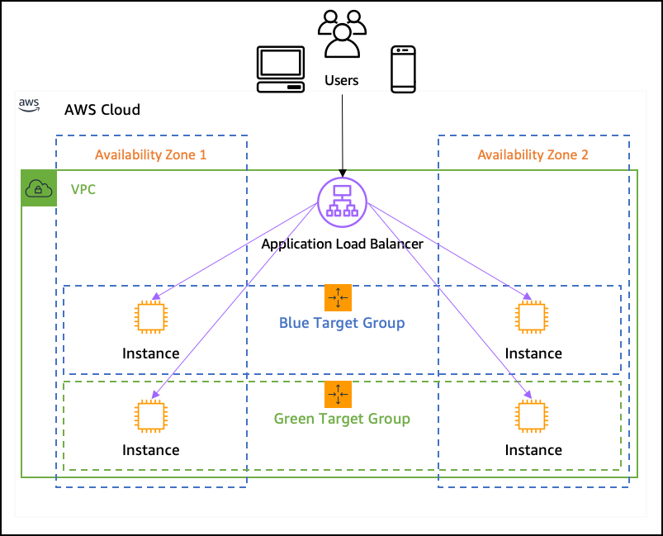

A target group tells a load balancer where to direct traffic to : EC2 instances, fixed IP addresses; or AWS Lambda functions, amongst others. When creating a load balancer, you create one or more listeners and configure listener rules to direct the traffic to one target group.

Load balancer always backend connect to target group

Each load balancer talk the multiple target group

13.Why we need to create target group?

In AWS, a target group serves the purpose of routing requests toward one or more registered targets. You can specify a target group for its default action upon creating a listener. The traffic is then directed to the target group specified in the listener rul

If u don't have target group

If we have load balancer

We don't have concept target group

We don't want route the traffic to the machine to public user

Bcz we need target group

We can register the group of machine

14.Wt is difference between cname record and type a record in route53?

A record mostly to name to IP address

U want nslookup ip

If want create the duplicate name we can use from existing name the canme record or alias record

 The A record maps a name to one or more IP addresses when the IP are known and stable. The CNAME record maps a name to another name. It should only be used when there are no other records on that name.

